**Staging Loads**

In SSDT **File>New>Project>Business Intelligence>Integration Services>Integration Services project**

In the newly created projected using connection managers under Solution Explorer I established connection to my source system which has data

Again using connection manager I established a connection to my target database where I want to stage loads

Under SSIS Packages under Solution Explorer I created a new package for staging loads

**Staging Loads Steps:**

1. In the new empty package created, I dropped multiple Execute SQL task in order to create TRUNCATE command so that every time my database is loaded it should clear existing data from table and reload data without creating duplicates.

Code used inside TRUNCATE boxes for each table is of form

**TRUNCATE TABLE TABLENAME** ***This is the name of the table which has data in your target database

1. I used data flow task to drop data flow boxes which when double clicked will allow to create source and destination to load data from source to target database
2. While dropping source box, Source Assistant allows to choose the source type which can be database/flat file/SQL SERVER etc
3. Double clicking source allows to choose tables from source database which can be loaded into target database
4. Dropping Destination box opens up Destination Assistant which allows to choose target database
5. Connecting destination to source box and double clicking newly created destination allows to create a table using New button with column names from table from Source table

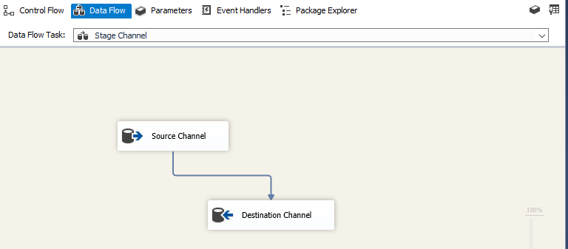

Repeating the process for all tables helps to stage all loads from source to target database

Executing loads sequentially will reduce server load but they can be executed in parallel

